WTC2024 展具租用申请表
WTC2024 Exhibition Equipment Rental Form

主场服务商联系方式Official Service Contractor
绿碳国际会展(深圳)有限公司  GREEN CARBON INTERNATIONAL EXHIBITION (SHENZHEN) CO., LTD. |  | 公司名称Exhibitor Name
 |  | 展位号Space No. |  | 展位面积Area
联系人Contact | 严 先生 Mr.Yan | 联系人Contact Person
手机Mobile Phone | +86 13560152334 | 手机Mobile Phone
邮箱Email: | order@wtc2024.cn | 邮箱Email

序号  No. | 类别  Category | 规格  Spec | 单价(元/个)  Unit Cost (CNY/pc) | 数量  Qty | 金额(元）  Amount (CNY)
桌子DESK/TABLE
01 | 铝型材咨询桌  Information Desk in Aluminum | 940L*450W*800H | ￥150 |  | ￥
02 | 洽谈桌（玻璃圆桌）  Negotiation Table  (Round & Glass) | 600L*750H | ￥60 |  | ￥
03 | 洽谈桌（白/黑/木纹）  Negotiation Table  (White/Black/Wood Grain) | 600L*750H | ￥150 |  | ￥
04 | 伊姆斯圆桌（白/黑/木纹）  Eames Table  (White/Black/Wood Grain) | 600L*750H | ￥150 |  | ￥
05 | 方桌（白/黑/木纹）  Square Table  (White/Black/Wood Grain) | 600L*750H | ￥150 |  | ￥
06 | 会议桌带桌布（可选配白、黑、红、墨绿、蓝色桌布）  Conference Table with Tablecloth  (Cloth colors: White/Black/Red/Dark Green/Blue) | 1200L*600W | ￥220 |  | ￥
07 | 圆吧台（白/黑/木纹）  Round Bar Table  (White/Black/Wood Grain) | 600L*750H | ￥240 |  | ￥
08 | 方吧台（白/黑/木纹）  Square Bar Table  (White/Black/Wood Grain) | 600L*750H | ￥240 |  | ￥
09 | 小方桌茶几（白、黑、木纹）  Small-size Square Coffee Table  (White/Black/Wood Grain) | 400L*400H | ￥120 |  | ￥
10 | 黑铁架双人茶几（玻璃、白、黑、木纹）  Black Iron Base Coffee Table for Two  (Top: Glass/White/Black/Wood Grain) | 1000L*600W*460H | ￥150 |  | ￥
11 | 圆茶几（白）  Round Coffee Table  (White/Black/Wood Grain) | 500L*400H | ￥150 |  | ￥
椅子CHAIR
12 | 白折椅  White Folding Chair | 460L*760H | ￥20 |  | ￥
13 | 葫芦椅  Gourd-shaped Chair | 450L*780H | ￥40 |  | ￥
14 | 伊姆斯椅  Eames Chair | 460L*810H | ￥60 |  | ￥
15 | 伊姆斯椅（带扶手）  Eames Chair with Armrests | 620L*800H | ￥60 |  | ￥
16 | 皮会议椅  Leather Conference Chair | 450L*780H | ￥40 |  | ￥
17 | 皮会议椅（旋转）  Leather Conference Swivel Chair | 550L*1020H | ￥180 |  | ￥
18 | 北欧轻奢单椅  Light Luxury Nordic Single Sofa Chair | 760L*830H | ￥580 |  | ￥
19 | 酒杯椅（旋转/木脚）  Cup Chair (Swviel/Wood Base) | 480L*790H | ￥90 |  | ￥
20 | 宴会椅  Banquet Chair | 460L*940H | ￥50 |  | ￥
21 | 升降旋转吧椅  Bar Chair (Swivel & Lifting) | 385*1040H | ￥60 |  | ￥
22 | 伊姆斯吧椅  Eames Bar Chair | 460L*1110H | ￥180 |  | ￥
23 | 单人方形沙发  Square Single Sofa | 750L*850H | ￥180 |  | ￥
24 | 沙发方凳  Square Ottoman | 400L*400H | ￥90 |  | ￥
25 | 双人方形沙发  Two-seat Square Sofa | 1500L*850H | ￥400 |  | ￥
26 | 长条皮沙发凳  Long Leather Ottoman | 1200L*400W*400H | ￥400 |  | ￥
27 | 单人北欧沙发椅  Nordic Single Seater | 630L*820H | ￥600 |  | ￥
28 | 高端会议沙发  High-end Conference Sofa | 900L*900W*1080H | ￥900 |  | ￥
展柜SHOWCASE
29 | 高陈列展柜  Tall Showcase | 1000L*300W*1820H | ￥200 |  | ￥
30 | 矮陈列展柜  Small Showcase | 1000L*300W*1450H | ￥160 |  | ￥
31 | 高玻璃展柜  Tall Glass Showcase | 950L*500W*1950H | ￥600 |  | ￥
32 | 铝型材珠宝展柜 （带射灯）  Aluminum Jewelry Showcase with Spotlights | 900L*500W*1000H | ￥400 |  | ￥
33 | 资料架  Catalog Stand | 270L*390H*1350H | ￥160 |  | ￥
展板PANEL
34 | 标准展位展板  Panel for Standard Booth | 1000L*2500H | ￥200 |  | ￥
35 | 平/斜层板  Flat/Tilting Panel | 1000L*300W | ￥60 |  | ￥
灯LED LIGHT
36 | 长臂射灯  Long-arm Spotlight | 35瓦 白/黄光  35W White/Yellow Light | ￥70 |  | ￥
37 | LED铲灯  Square LED Spotlight | 70瓦 白/黄光  70W White/Yellow Light | ￥150 |  | ￥
38 | LED金卤灯  LED Metal Halide Lamp | 150瓦 白/黄光  150W White/Yellow Light | ￥220 |  | ￥
39 | 五孔插座  Five-hole Socket | 国标插口  Chinese Standard Voltage | ￥100 |  | ￥
40 | 4孔位排插  Four-outlet Power Strip | 多国通用插口1.5米线  Universal Voltage  1.5m Extension | ￥100 |  | ￥
电视&触摸屏TV & SCREEN
41 | 液晶电视（需自带U盘播放，视频播放格式MP4）  LED TV  (Videos should be prepared in MP4 format and saved in a USB) | 42寸/台  42 inches | ￥800 |  | ￥
42 |  | 50寸/台  50 inches | ￥1000 |  | ￥
43 |  | 55寸/台  55 inches | ￥1100 |  | ￥
44 |  | 65寸/台  65 inches | ￥1600 |  | ￥
45 |  | 75寸/台  75 inches | ￥2200 |  | ￥
46 | 液晶电视落地支架  LED TV Floor Stand |  | ￥100 |  | ￥
47 | 横式触摸屏  Horizontal Touchscreen | 42寸挂墙/台  42 inches, wall-mounted | ￥1600 |  | ￥
48 |  | 55寸挂墙/台  55 inches, wall-mounted | ￥2100 |  | ￥
49 |  | 65寸挂墙/台  65 inches, wall-mounted | ￥2350 |  | ￥
50 | 横式触摸屏落地支架底座  Floor Stand for Horizontal Touchscreen |  | ￥100 |  | ￥
51 | 竖式触摸屏  Vertical Touchscreen | 42寸挂墙/台  42 inches, wall-mounted | ￥1600 |  | ￥
52 |  | 55寸挂墙/台  55 inches, wall-mounted | ￥2400 |  | ￥
53 |  | 65寸挂墙/台  65 inches, wall-mounted | ￥2600 |  | ￥
54 |  | 75寸挂墙/台  75 inches, wall-mounted | ￥4200 |  | ￥
55 | 竖式广告机  Vertical Advertsing Player | 42寸落地/台  42 inches, wall-mounted | ￥1200 |  | ￥
56 |  | 55寸落地/台  55 inches, wall-mounted | ￥2200 |  | ￥
音响设施 Speaker
57 | 拖拉式移动音响  Portable Trolley Speaker | 带2个无线手持麦克风  With 2 Wireless Handheld Mic | ￥800 |  | ￥
喷绘SPRAYING
58 | 灯布喷绘  Flex Banner Spraying | 每㎡含制作安装  Per ㎡ with installment included | ￥60 |  | ￥
59 | 阻燃网格布喷绘  Flame Retardant Fabric Spraying | 每㎡含制作安装  Per ㎡ with installment included | ￥90 |  | ￥
60 | 安迪板喷绘  PVC Sheet Spraying | 每㎡含制作安装  Per ㎡ with installment included | ￥120 |  | ￥
61 | 雪弗板喷绘  Chevalet Sheet Spraying | 每㎡含制作安装  Per ㎡ with installment included | ￥180 |  | ￥
62 | 热转移布喷绘  Heat Transfer Fabric Spraying | 每㎡含制作安装  Per ㎡ with installment included | ￥140 |  | ￥
63 | 车贴  Car Sticker | 每㎡含制作安装  Per ㎡ with installment included | ￥80 |  | ￥
64 | 地贴  Floor Sticker | 每㎡含制作安装  Per ㎡ with installment included | ￥120 |  | ￥
65 | X展架  X-Framed Banner Stand | 个  Per piece | ￥100 |  | ￥
66 | 易拉宝（0.8*2米）  Roll-up Banner (0.8W*2H) | 个  Per piece | ￥150 |  | ￥
67 | 门型展架（0.8*1.8米）  Door-shaped Banner Stand | 个  Per piece | ￥180 |  | ￥
地毯CARPET
68 | 300g普通展览地毯  300g Standard Exhibition Carpet | 多种颜色B1级阻燃每㎡  Different Colors Available, B1 Flame Retardant, per ㎡ | ￥26 |  | ￥
69 | 拉绒地毯  Brushed Carpet | 多种颜色B1级阻燃每㎡  Different Colors Available, B1 Flame Retardant, per ㎡ | ￥50 |  | ￥
70 | 办公地毯  Office Carpet | 多种颜色B1级阻燃每㎡  Different Colors Available, B1 Flame Retardant, per ㎡ | ￥70 |  | ￥
其他OTHER
71 | 竖式冰箱  Upright Refrigerator | 45L | ￥800 |  | ￥
72 |  | 90L | ￥1200 |  | ￥
73 |  | 180L | ￥1600 |  | ￥
74 |  | 220L | ￥1800 |  | ￥
75 | 卧式冰箱  Chest Refrigerator | 325L | ￥1200 |  | ￥
76 | 立式饮水机带1桶水  Vertical Water Dispenser with 1 barrel of water | 下置式  With water barrel placed underneath | ￥240 |  | ￥
77 | 桶装水  Barreled Water | 每桶  Per Barrel | ￥60 |  | ￥
78 | 饮用一次性纸杯  Disposable Paper Cup | 100个每项  100 cups per order | ￥40 |  | ￥
79 | 拆除展位  Booth Dismantlement | 3*3 9㎡ | ￥600 |  | ￥
80 | 移动白板  Portable Whiteborad | 1200L*900H | ￥440 |  | ￥
81 | 垃圾桶  Dustbin | 白/黑/银色 | ￥20 |  | ￥
82 | 隔离带  Retratable Isolation Belt | 1米 黑色柱身配黑/蓝/红色  1m, Black Base with Black/Blue/Red Belt | ￥40 |  | ￥
83 | 礼宾带  Folding-type Isolation Belt | 1米 金色柱身配黑/红/金色  1m, Golden Base with Black/Red/Golden Belt | ￥50 |  | ￥
84 | 演讲台  Rostrum | 白色600*420*1100H  White 600*420*1100H | ￥300 |  | ￥
85 | 名片收集盒  Business Card Collector | L220*W120*H130 | ￥120 |  | ￥
86 | 安全帽  Hard Hat | 布展期需佩戴  Necessary during the move-in period | ￥30 |  | ￥
87 | 干粉灭火器  Dry Powder Fire Extinguisher | 手提式4kg  Portable | ￥60 |  | ￥
88 |  | 宫灯式4kg  Ceiling Mounted | ￥60 |  | ￥
合计Total (人民币/ CNY ) |  |  |  |  | ￥

日期Date：

签字盖章Signature/Stamp：

说明 Description
- 以上所有价格均为2024世界隧道大会展期的租赁价格，展会结束后不得自行带走。
Above prices are for WTC2024 exhibition period,and equipment SHALL NOT be taken away after the exhibition.
- 以上租赁项目，请提前申请，在2024年3月31日前支付享受以下优惠政策：
The following benefits are provided if you reserve the booths and pay before the due date:
- 截止2024年2月29日前完成预定并支付全部款项：享受订单总金额8折优惠
Complete reservation and full payment by 29th February 2024: 20% off the total amount
- 截止2024年3月31日前完成预定并支付全部款项：享受订单总金额9折优惠；
Complete reservation and full payment by 31st March 2024: 10% off the total amount
- 从2024年4月1日（含当日）起不享受任何优惠政策，且不保证供应。
No preferential policy will be available from 1 April 2024 (inclusive).
- 已预订/安装展位的展具，如需退换或移位，需收取租赁价格的50%作为手续费。
There is a 50% handling charge of the rental price for shifting, replacing or returning exhibition equipment that has already been booked or installed.
- 根据展馆及消防规定，标准展位的插座仅限用于电脑、饮水机及手机充电使用，不得私自接灯。
According to safety regulations, the sockets provided for Exhibition Booths are used for computers/laptops,water dispensers, and cellphones ONLY. It is not allowed to connect lights.
- 标准配置的展具物品不得作有价退或换，展商不得私自搬拿其他展位上的物品。
No refunds will be possible for replacing or returning exhibition equipment provided for Exhibition Booths. Exhibitors SHALL NOT take any equipment from other booths without permission.
- 如需租赁以上表格没有项目请联系大会主场服务商咨询租赁。
Please contact Official Service Contractor if the equipment you requested is not on the form above.

展具租赁样式图
Images of Exhibition Equipment

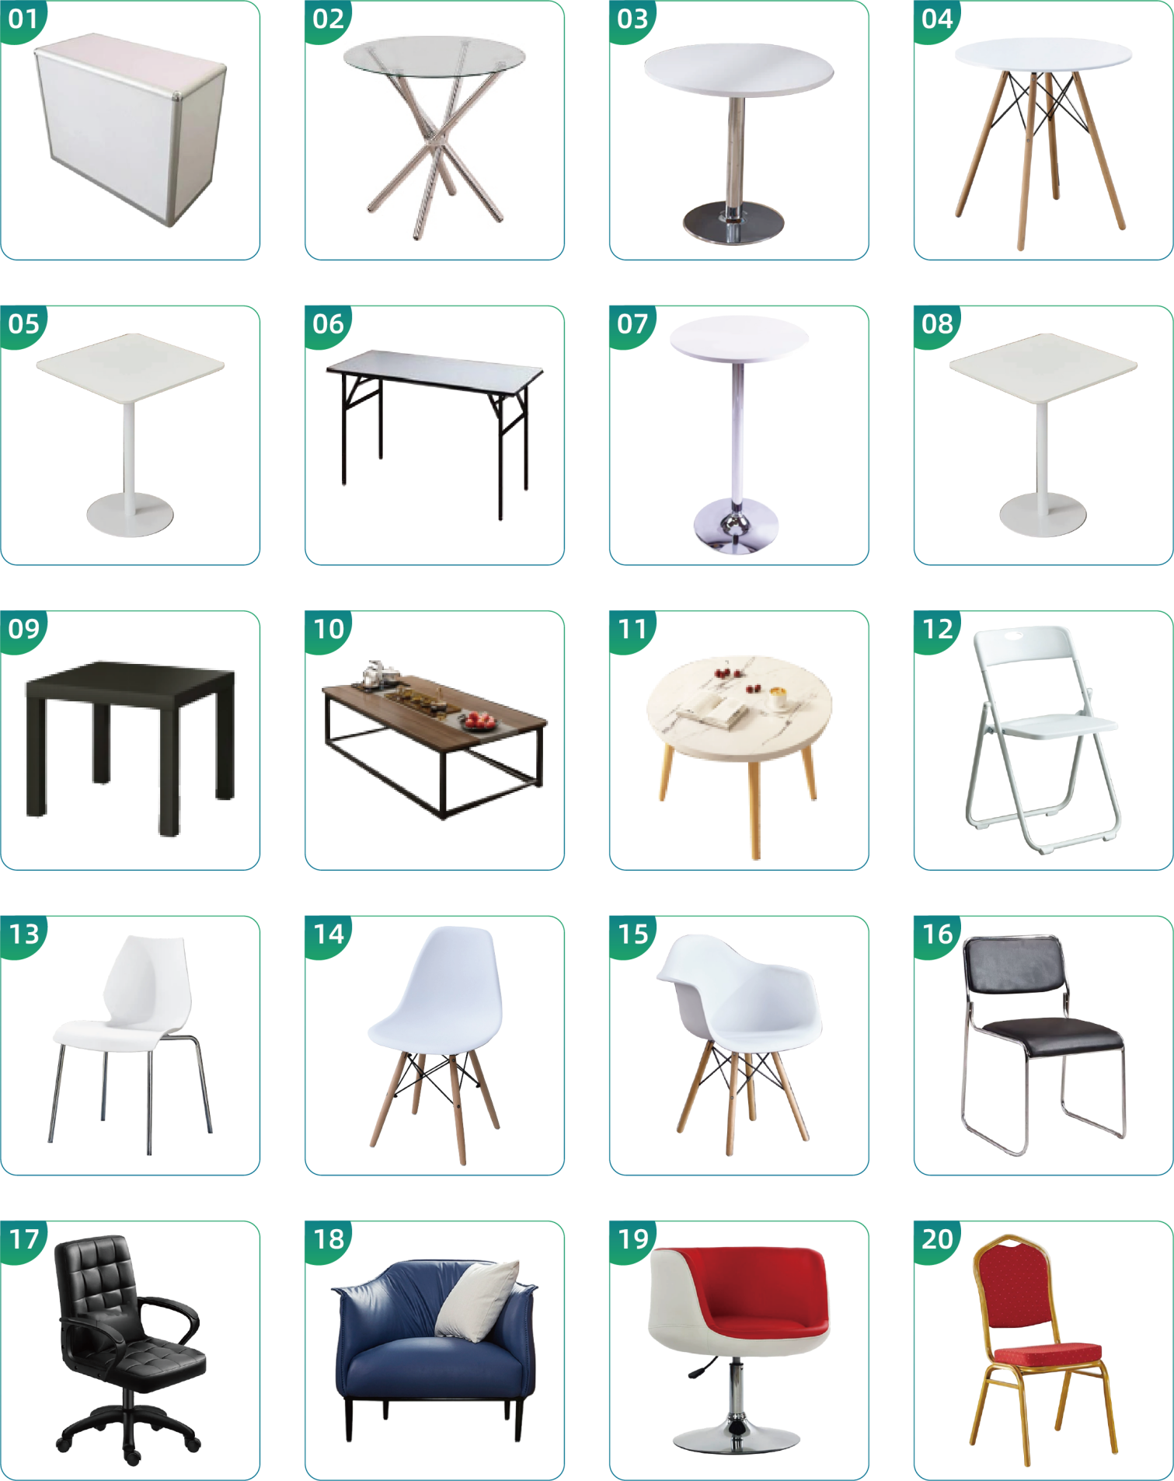

展具租赁样式图
Images of Exhibition Equipment
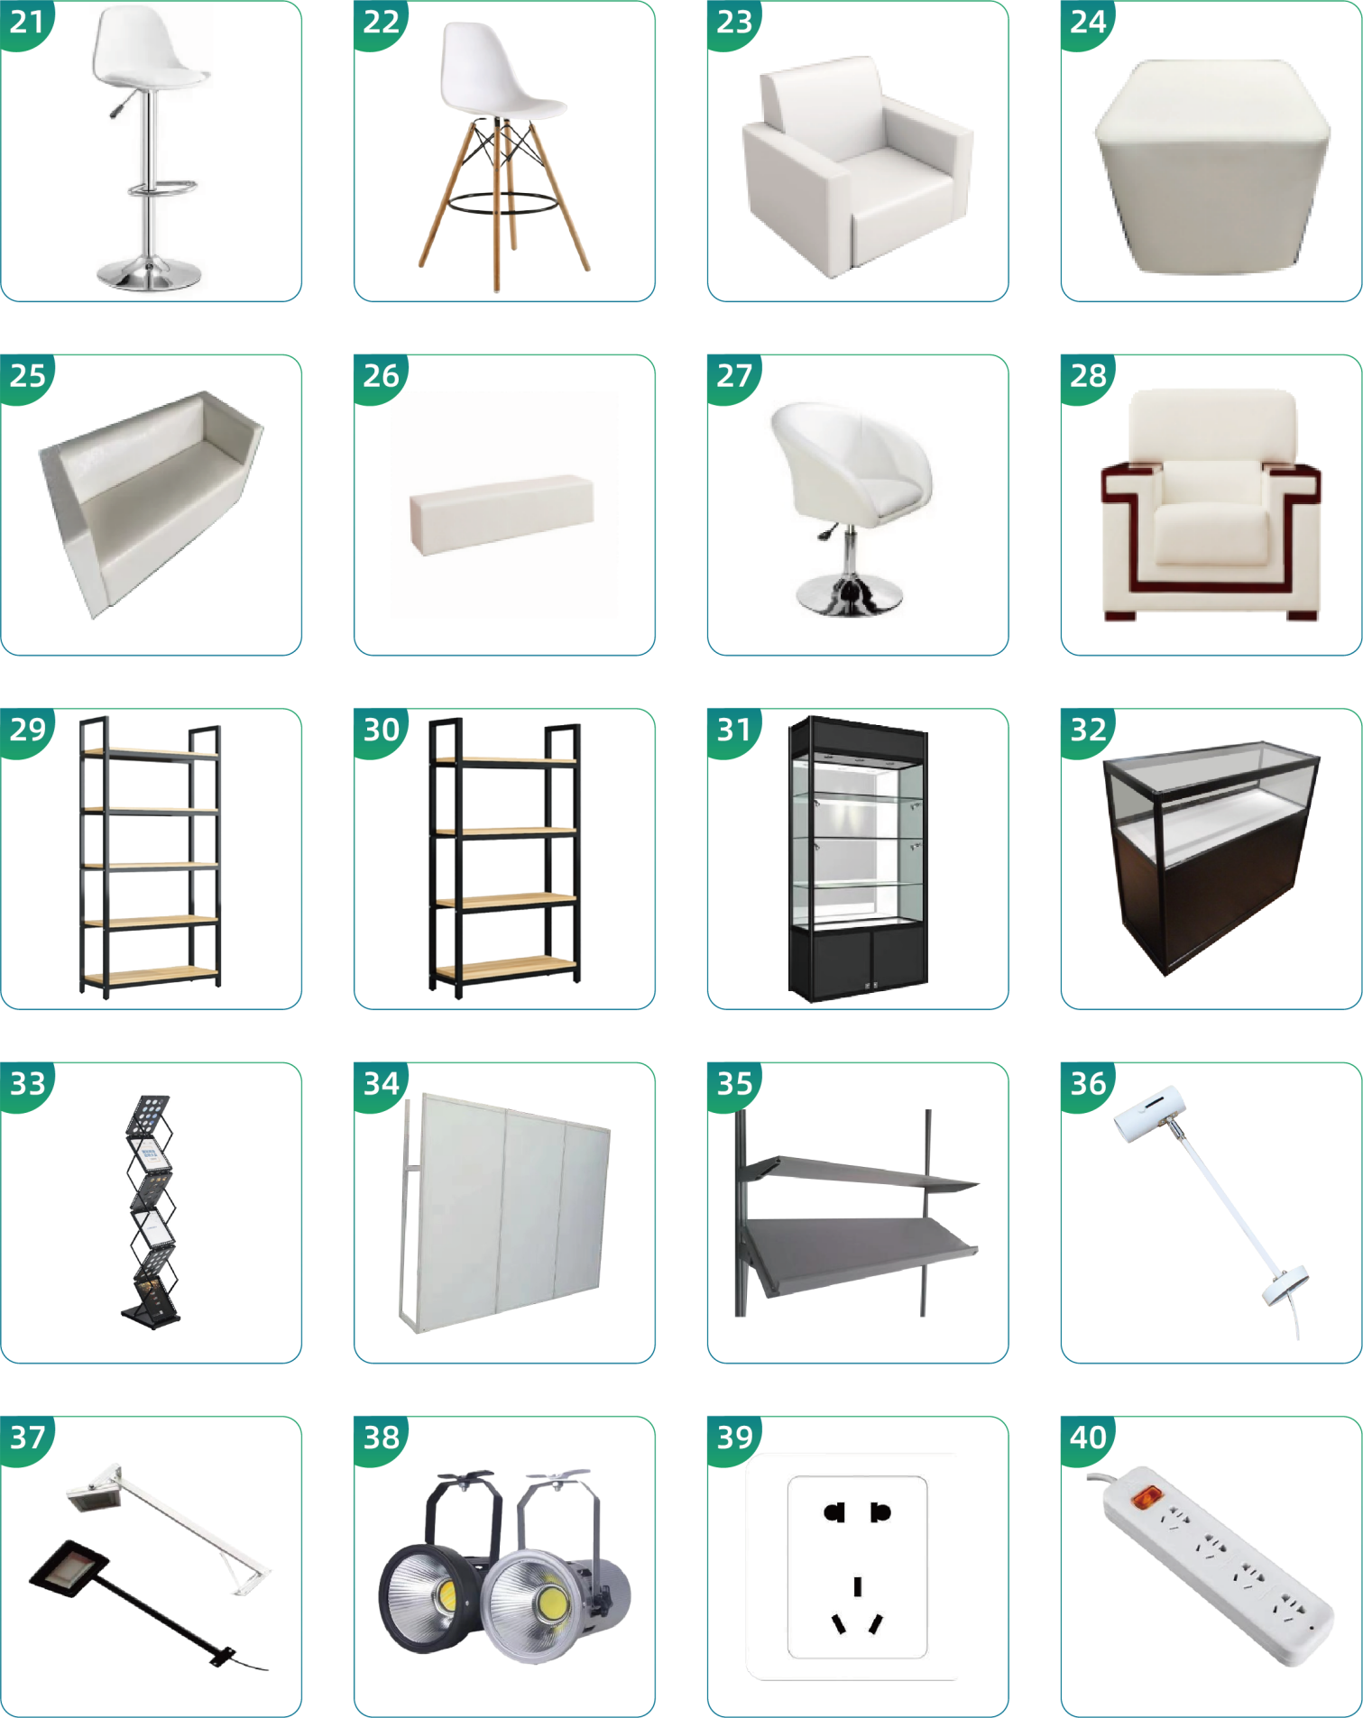

展具租赁样式图
Images of Exhibition Equipment
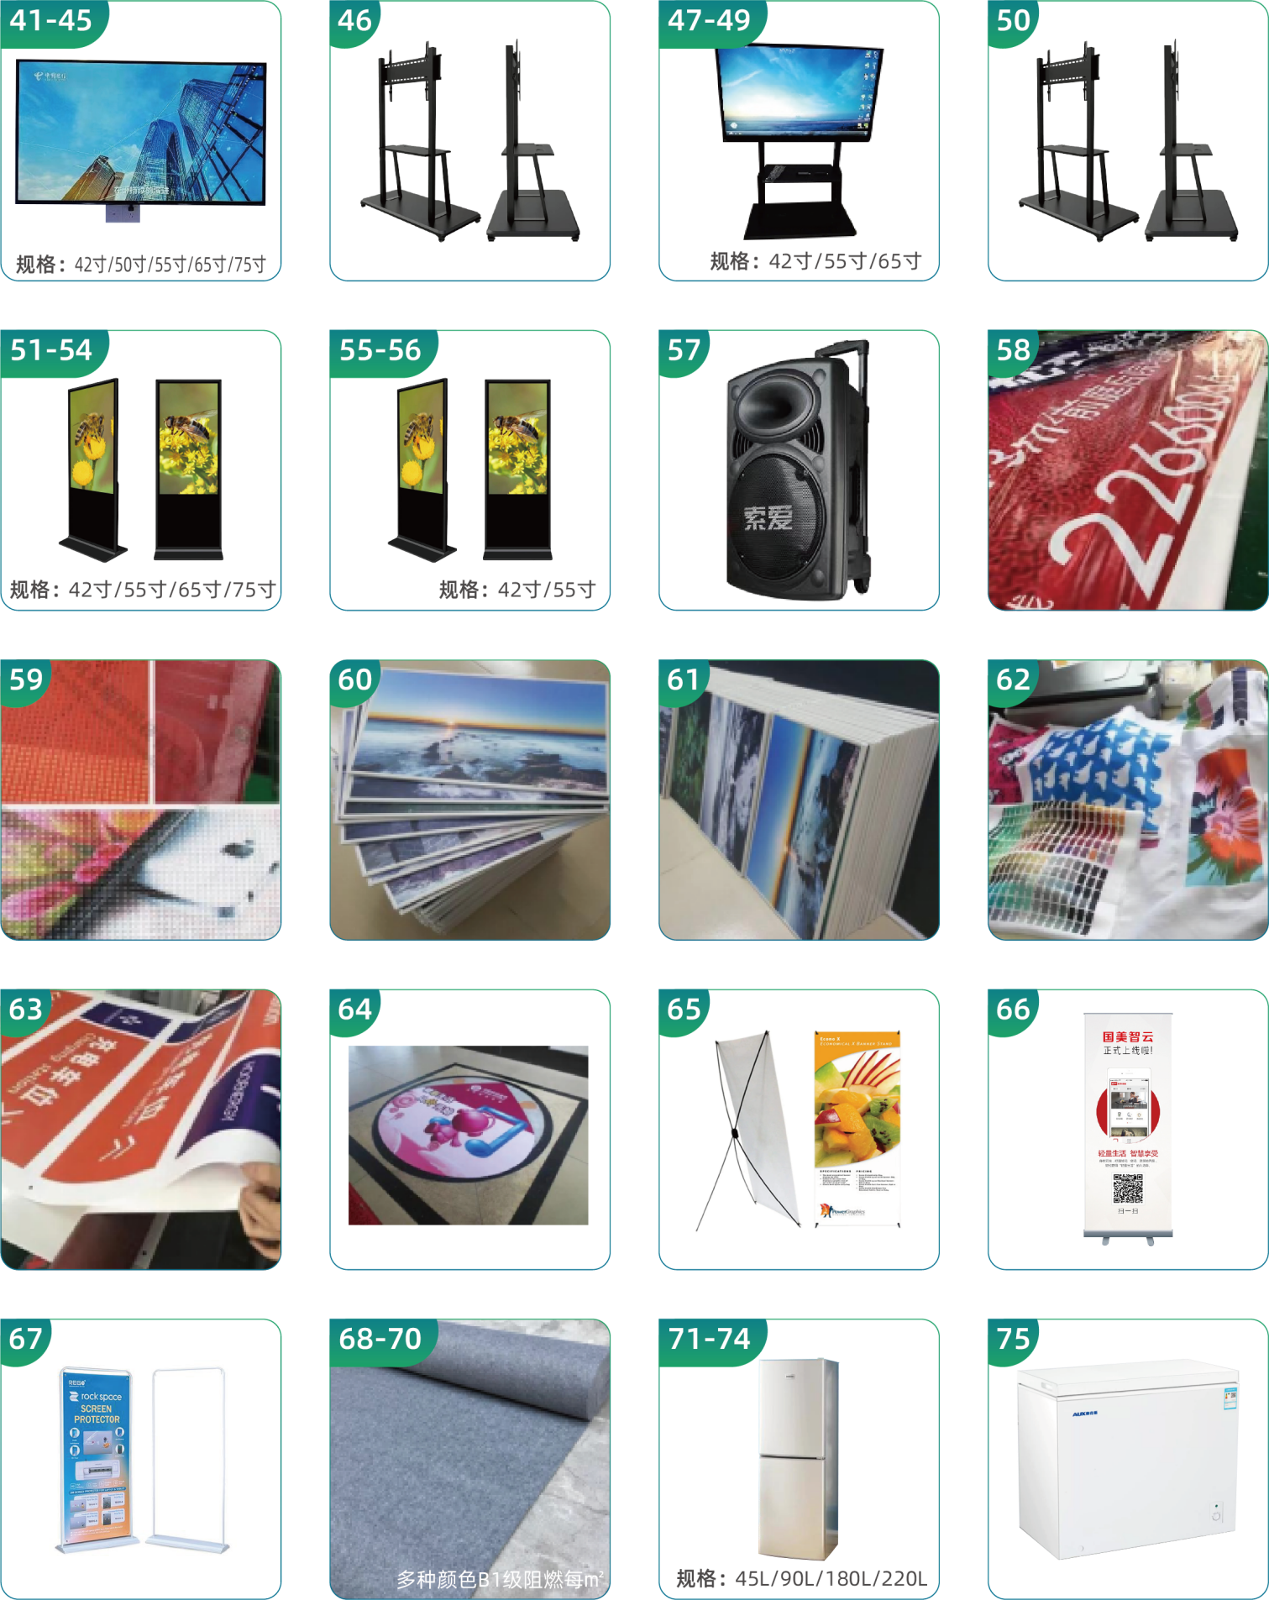

展具租赁样式图
Images of Exhibition Equipment
